Project Design Phase-II
Technology Stack (Architecture & Stack)
Date | 19 Jul 2026
Team ID
Project Name | AI-powered Job Recruitment & Candidate Management System
Maximum Marks | 2 Marks

Technical Architecture
System Flow
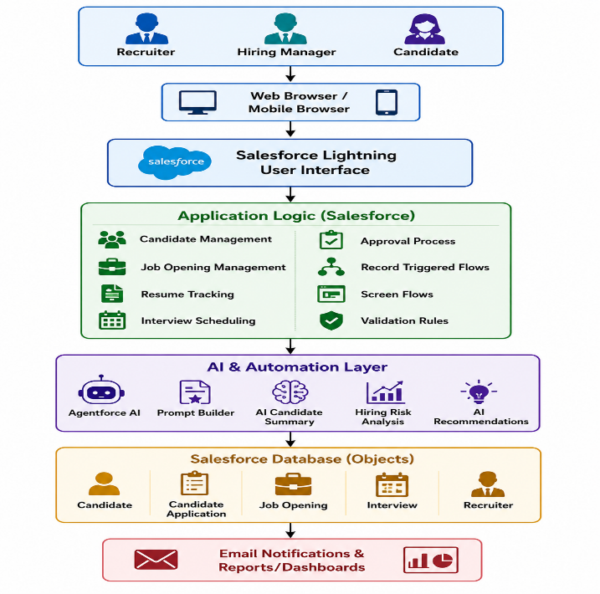

Table-1 : Components & Technologies
S.No | Component | Description | Technology
1 | User Interface | Recruiters, Hiring Managers, and Candidates interact through a web application | Salesforce Lightning Experience, HTML, CSS, JavaScript
2 | Application Logic-1 | Candidate registration, job posting, interview scheduling | Salesforce Flows, Apex (optional), Validation Rules
3 | Application Logic-2 | Recruitment workflow automation | Record Triggered Flows, Screen Flows
4 | Application Logic-3 | AI-powered recruitment assistance | Salesforce Agentforce, Prompt Builder
5 | Database | Stores candidate, recruiter, interview, and job details | Salesforce CRM Objects
6 | Cloud Database | Cloud-based data storage | Salesforce Cloud Platform
7 | File Storage | Resume and document storage | Salesforce Files
8 | External API-1 | Email notifications | Salesforce Email Services
9 | External API-2 | Authentication & Identity Management | Salesforce Identity
10 | Machine Learning Model | Candidate evaluation and hiring recommendations | Salesforce Einstein AI / Agentforce AI
11 | Infrastructure (Server/Cloud) | Cloud deployment | Salesforce Cloud Infrastructure

Table-2 : Application Characteristics
S.No | Characteristics | Description | Technology
1 | Open-Source Frameworks | Front-end technologies and standard web technologies | HTML5, CSS3, JavaScript
2 | Security Implementations | Role-based access, profile permissions, authentication, encryption | Salesforce Security Model, Role Hierarchy, Profiles, Permission Sets, MFA
3 | Scalable Architecture | Multi-tier cloud architecture supporting thousands of users | Salesforce Multi-Tenant Cloud Architecture
4 | Availability | High availability with cloud infrastructure and automatic backup | Salesforce Cloud Platform
5 | Performance | Optimized workflows, indexed database, reports, dashboards, and AI processing | Salesforce Platform Optimization, Flow Automation, Lightning Framework

Technology Stack Summary
Layer | Technology
Frontend | Salesforce Lightning Experience, HTML5, CSS3, JavaScript
Backend | Salesforce CRM, Apex, Flow Builder
AI Layer | Salesforce Agentforce, Prompt Builder, Einstein AI
Database | Salesforce CRM Database
Automation | Record Triggered Flows, Screen Flows, Approval Processes
Security | Profiles, Roles, Permission Sets, MFA, Encryption
Storage | Salesforce Files
Reporting | Salesforce Reports & Dashboards
Cloud Platform | Salesforce Cloud

Architecture Explanation
The AI-Powered Job Recruitment & Candidate Management System is built on the Salesforce Cloud Platform using a multi-tier architecture. Recruiters, hiring managers, and candidates access the application through Salesforce Lightning Experience. The application logic is implemented using Salesforce Flows, Validation Rules, Approval Processes, and Apex (where required). AI capabilities such as candidate evaluation, hiring risk analysis, and recruitment recommendations are provided through Agentforce and Prompt Builder. Candidate records, job openings, interview schedules, and recruitment workflows are securely stored in Salesforce CRM Objects. The platform provides role-based security, cloud scalability, automated workflows, email notifications, reports, and dashboards to streamline the recruitment process.

